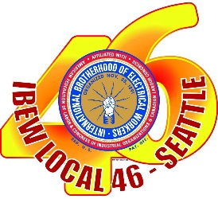

Hello Members of Local 46!

This is an update regarding the Portland Plan / Harrison Trust Drug Free Workplace random drug testing program. It has been about 10 weeks since the Portland Plan decided to re-start the random drug testing. But now due to the spike in COVID cases across the region, they have informed us that random testing is again being temporarily suspended. The Program will NOT be sending out any new random test lists for the time being, until further notice.

The point person for Local 46 is Dispatcher Bryan Johnson. Please contact him at bryan@ibew46.com if you have any questions.

Thank you and stay safe!

Sean Bagsby
Business Manager
IBEW 46

ra/opeiu8/afl-cio

