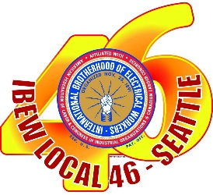

WOMEN BUILD NATIONS CONFERENCE 2021
CANCELLED

It makes me sad to deliver this news.

Due to damage caused by Hurricane Ida to New Orleans and Louisiana the NABTU has officially announced that the Women Build Nations Conference scheduled for October 1-3, 2021 has been cancelled.

No other information has been provided – if any more information is released we will post an update.

Please contact me if you have any questions.

Laura J Robinson (pronouns: she/her)
Broadcast Representative/Assistant Educational Coordinator
IBEW Local 46
(253) 395-6505 Office
(253) 259-0339 Cell
Laura@IBEW46.com

ra/opeiu8/afl-cio

