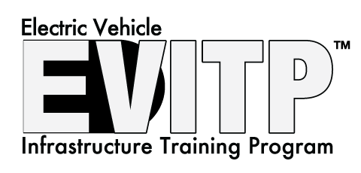
About EVITP: The Electric Vehicle Infrastructure Training Program (EVITP) provides the most comprehensive training and certification for the installation of electric vehicle supply equipment in North America. More than a technical installation course, EVITP offers a full overview of the electric vehicle industry including applicable building codes, load calculations, commissioning, troubleshooting, and customer relations.
About the Class:
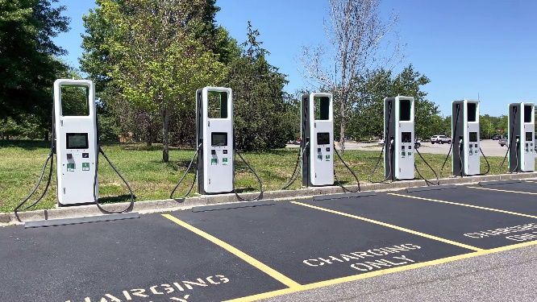
The class is presented in a hybrid structure with the course materials presented online and through in-person lectures. The course is approved for 12 CEU hours with Washington State.
Online portion: (estimated 8-12 hours)
The online portion of the class utilizes the Electrical Training Alliance computer mediated course that includes training modules and quiz type questions. The time commitment for this portion of the class is estimated at 8-12 hours. Participants will be required to have a computer (laptop or PC) and internet access to complete the course.
In-person portion: (18 hours)
The in-person portion of the class will consist of four evening sessions on Tuesdays and Thursdays, from 5 – 8:30PM, with one additional Tuesday or Thursday evening for testing, at the Puget Sound Electrical JATC.
Certification:
To be eligible for EVITP certification, a participant must be a state licensed electrician. To become certified, participants must complete the EVITP course and successfully pass the EVITP certification exam.
Cost:
Online content fee is $85.00
EVITP Class Dates:
Class # In Person Class Dates Test Dates
2025 – 1 2/25, 2/27, 3/4 and 3/6 3/11 and/or 3/13
2025 – 2 5/13, 5/15, 5/20 and 5/22 5/27 and/or 5/29
2025 – 3 8/12, 8/14, 8/19 and 8/21 8/26 and/or 8/28
2025 – 4 11/4, 11/6, 11/11 and 11/13 11/18 and/or 11/20
Please visit PSEJATC.org and register under the Journeyman class schedule tab.

